PROJECT REPORT
Automated Network Request Management in ServiceNow

ServiceNow Global Certification Programme (Skill Wallet)
Project type | Individual project (no team)
Submitted by | Pentareddy Ruhin
Platform | ServiceNow Personal Developer Instance
Date | 4 October 2026

Contents
1. Introduction
2. Ideation Phase
3. Requirement Analysis
4. Project Design
5. Project Planning & Scheduling
6. Functional and Performance Testing
7. Results
8. Advantages & Disadvantages
9. Conclusion
10. Future Scope
11. Appendix

1. INTRODUCTION

1.1 Project Overview
This project automates the end-to-end lifecycle of network-related service requests in ServiceNow. A user submits a Network Request from the Service Portal. The platform captures the details, stores them in a custom table (u_database_tables), sends a confirmation email, routes the request to the System Administrator for approval, and then updates the record and sends a resolved email based on the decision.
The solution uses configuration only: a catalog item with variables, a variable set that auto-fills requester details, a catalog UI policy, a custom table with an approvals related list, and one Flow Designer flow.

1.2 Purpose
- Reduce manual effort and human error in handling network requests.
- Speed up fulfilment with automatic record creation and approval routing.
- Enforce one standard form and approval process.
- Give requesters and administrators visibility through records, emails, flow logs and Activities.
- Support compliance with an audit trail of approvals and field changes.

2. IDEATION PHASE

2.1 Problem Statement
Employees cannot easily raise and track network requests because the process is manual and handled by email. Three views of the problem were written:
PS | I am | I'm trying to | But | Because | Which makes me feel
PS-1 | An employee (requester) | request a network connection or change and track it | I cannot see what happens to my request | requests are handled manually by email with no tracking | Uncertain and frustrated
PS-2 | An approver | approve or reject requests quickly | requests reach me late with incomplete details | approvals are routed manually with no audit trail | Overloaded and worried about compliance
PS-3 | A network fulfilment team member | process requests accurately | data arrives incomplete and in different formats | there is no single form or automatic record creation | Stressed and error-prone

PS-1 was selected as the problem the project addresses. PS-2 and PS-3 are covered by the same solution.

2.2 Empathy Map Canvas
Persona: an employee (requester) who needs a new network connection or a change and raises it through the Service Portal.
Think & Feel | Hear
Will my request be handled quickly?  I do not know if it was approved.  I worry about entering a wrong detail. | Colleagues say requests take days and give no status.  IT says to raise a request and wait.  The confirmation says it will be resolved in 2 business days.
See | Say & Do
A long catalog form.  Emails asking for missing details.  No clear status after submitting. | Opens the portal and searches for Network Request.  Fills in the form and orders.  Waits for the confirmation email.
Pain | Gain
Manual follow-ups by email or phone.  Retyping name, email and phone.  No visibility of status. | A simple form with auto-filled details.  Instant request number.  Automatic approval and email notifications.

2.3 Brainstorming
The ideation was done individually. Ideas were grouped and then ranked by impact and effort:
Group | Ideas listed
A. Request intake | Network Request catalog item; seven variables; UI policy for Existing ID; variable set that auto-fills email, name and phone; mandatory fields
B. Automation | Flow on catalog submission; automatic record creation; automatic approval and status update; automatic assignment
C. Communication | Confirmation email; Resolved email; rejection email; Teams or Slack notifications
D. Tracking and control | Custom table with approvals related list; audit and Activities; ACLs; dashboards and SLA reports
E. Future scope | Network Task table; approvers by request type or priority; reminders for pending approvals

# | Idea | Impact | Effort | Decision
1 | Catalog item with variables | High | Low | Implemented
2 | Auto-populate requester details | Medium | Low | Implemented
3 | UI policy for Existing ID | Medium | Low | Implemented
4 | Flow: create record and confirmation email | High | Medium | Implemented
5 | Approval routing and status update | High | Medium | Implemented
6 | Resolved email after approval | Medium | Low | Implemented
7 | Audit and Activities | Low | Low | Implemented
8 | Network Task table | High | High | Future scope
9 | Dashboards and SLA reports | Medium | High | Future scope
10 | Approvers by request type or priority | Medium | Medium | Future scope

3. REQUIREMENT ANALYSIS

3.1 Customer Journey Map
Persona: employee (requester). The map follows five stages. It is based on our analysis of the process and on testing the solution, not on user interviews.
Stage | Steps | Goal | Pain point | Opportunity
Entice | Needs a network change; finds Network Request in the portal | Find the right service quickly | Without a catalog item, people email IT | Promote the item on the portal home page
Enter | Opens the form; picks a user; details auto-fill | Avoid retyping details | Details typed again without auto-fill | Pre-fill more fields
Engage | Fills the form; chooses connection type; orders; gets a request number | Raise the request correctly in one go | Forgotten mandatory fields block submission | Add field help and format checks
Exit | Approver decides; record updates; emails arrive | Get a fast, clear decision | Approval waits if the approver is slow | Add approval reminders and a rejection email
Extend | Checks the record and status; raises the next request | See what happened to the request | No requester dashboard yet | Add a status tracker and dashboards

3.2 Solution Requirements
Functional requirements
FR | Requirement | Sub requirements
FR-1 | Request submission through the Service Portal | Open the item; enter request details; choose New or Existing; Order Now and Checkout; get a request number
FR-2 | Auto-population of requester details | Email, User Name and Phone Number fill in after selecting a user
FR-3 | Dynamic form behaviour and validation | Existing ID shown only for Existing; Mobile Number and Total Amount mandatory
FR-4 | Automatic record creation | Flow creates a record in Database Tables with Approval Status = Requested
FR-5 | Email notifications | Created email on creation; Resolved email after approval
FR-6 | Approval routing | Approval request to the System Administrator; approve or reject from the approvals list or related list
FR-7 | Automatic status update | Approved: Approved and ITIL User. Rejected: Rejected and Abraham Lincoln
FR-8 | Tracking and audit | Approval Request related list; Activities; flow and email logs

Non-functional requirements
NFR | Requirement | Description
NFR-1 | Usability | One short form, mandatory fields marked, requester details auto-filled, Existing ID shown only when needed
NFR-2 | Security | Default ACLs on the custom table, role-based access, approval only by the assigned approver
NFR-3 | Reliability | Every flow run is logged with its state and error; approve and reject paths were tested end to end
NFR-4 | Performance | Flow starts right after submission and uses configuration only, with no custom scripts in the request path
NFR-5 | Availability | Runs on the ServiceNow cloud; a developer instance can hibernate when inactive
NFR-6 | Scalability | New request types need only new variables or items; the table can take extra fields

3.3 Data Flow Diagram
The Level 1 data flow diagram is on the next page. The requester submits a request. Process 2.0 creates the record and sends the confirmation email. Process 3.0 asks for approval, and process 4.0 updates the record and sends the resolved email.
User stories
USN | User story | Priority | Sprint
USN-1 | As a requester, I can open the Network Request item and see the request form | High | Sprint-1
USN-2 | As a requester, I can pick a user so that email, name and phone fill in | Medium | Sprint-1
USN-3 | As a requester, I can choose the connection type and enter an existing ID only when needed | Medium | Sprint-1
USN-4 | As a requester, I can submit with Mobile Number and Total Amount | High | Sprint-1
USN-5 | As a requester, I receive an email when my request is created | High | Sprint-2
USN-6 | As a requester, I receive an email when my request is resolved | Medium | Sprint-2
USN-7 | As an approver, I receive an approval request for every new request | High | Sprint-2
USN-8 | As an approver, I can approve or reject a request | High | Sprint-2
USN-9 | As an administrator, I can see Approval Status and assignment on the record | High | Sprint-2
USN-10 | As an administrator, I can check flow and email logs to find problems | Medium | Sprint-3
USN-11 | As an administrator, I can see field changes in Activities | Low | Sprint-3

3.3 Data Flow Diagram
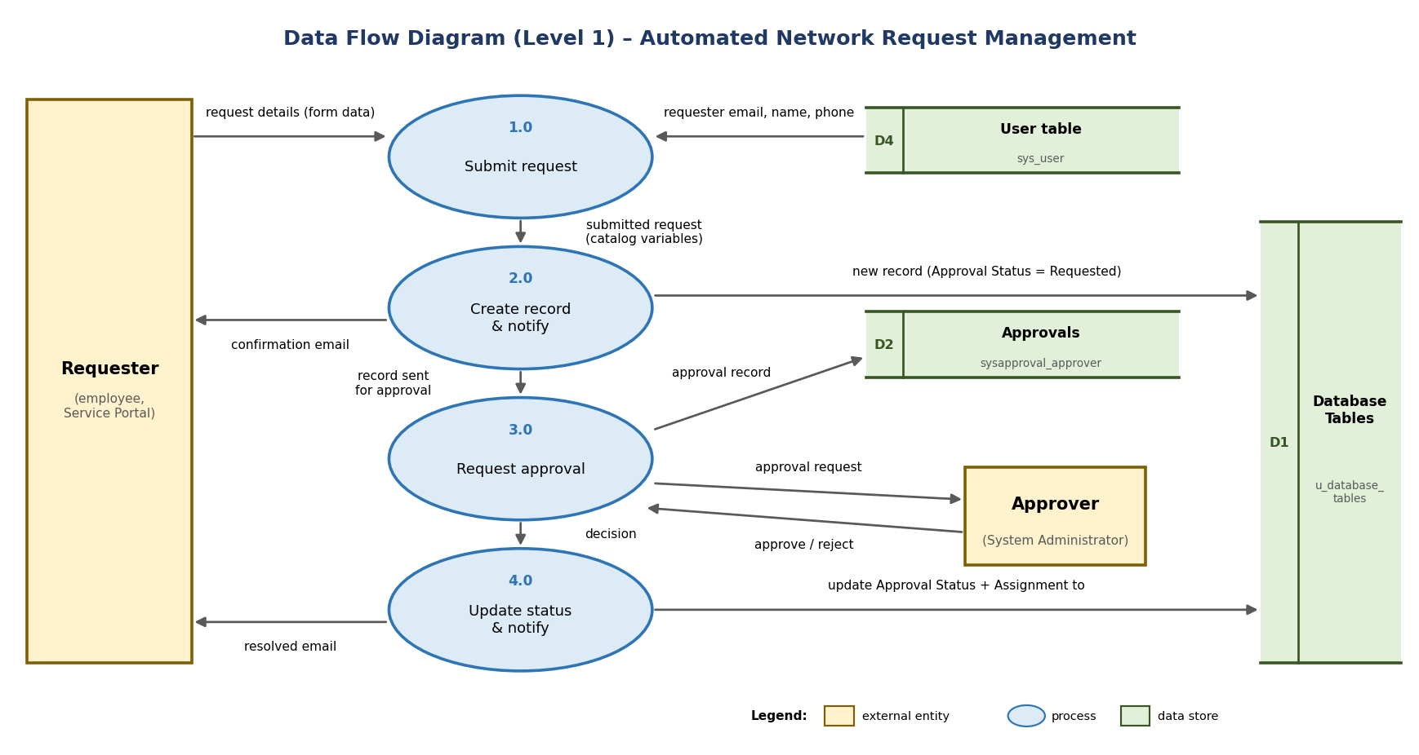
Figure 1: Level 1 data flow diagram

3.4 Technology Stack
S.No | Component | Description | Technology
1 | User Interface | Requesters raise requests in the portal; approvers use the approvals list | Service Portal (/sp), Service Catalog item, catalog variables and UI policy
2 | Application Logic-1 | Trigger on catalog submission, get variables, create the record | Flow Designer (Service Catalog trigger, Get Catalog Variables, Create Record)
3 | Application Logic-2 | Ask for approval, then update the record for Approved or Rejected | Flow Designer (Ask For Approval, If / Else, Update Record)
4 | Application Logic-3 | Created and Resolved emails | Flow Designer Send Email action
5 | Database | Custom table u_database_tables; platform tables for approvals, users and emails | ServiceNow platform relational database
6 | Cloud Database | Hosted with the instance; no separate service | ServiceNow cloud (developer instance)
7-10 | File storage, External APIs, ML model | Not used | Not applicable
11 | Infrastructure | Deployed on the ServiceNow cloud; server managed by ServiceNow | ServiceNow Personal Developer Instance (Global scope)

S.No | Characteristic | Description | Technology
1 | Open-source frameworks | None; built with low-code tools | Flow Designer, Service Catalog, UI policies
2 | Security | Default ACLs, roles, platform login, approval by the assigned approver | ServiceNow ACLs and roles
3 | Scalable architecture | Presentation, logic and data layers; new variables, items or flows can be added | ServiceNow platform architecture
4 | Availability | Cloud hosted; a developer instance may hibernate when inactive | ServiceNow cloud hosting
5 | Performance | Configuration only; flow starts right after submission | Flow Designer engine

3.4 Technology Stack: architecture diagram
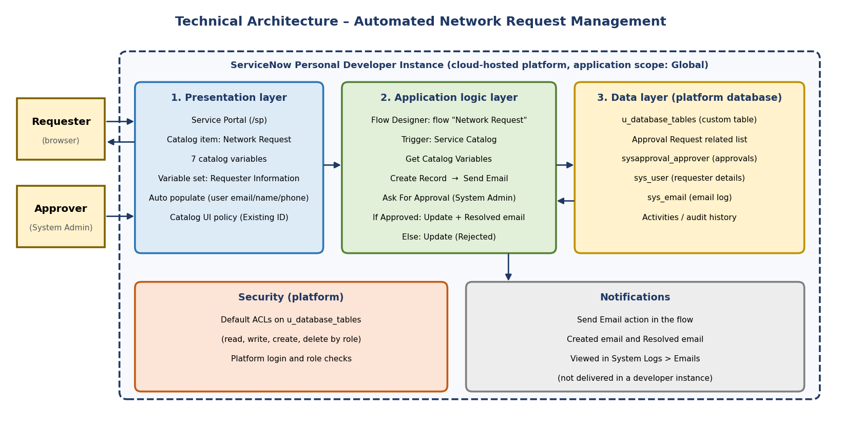
Figure 2: Technical architecture

4. PROJECT DESIGN

4.1 Problem Solution Fit
Section | Our project
Customer segments | Employees (requesters); approvers; network fulfilment team and IT administrators
Jobs-to-be-done / problems | Raise a request quickly and correctly; know its status; get a fast approval; receive complete data
Triggers | A new connection or change is needed; a manager asks for a formal request; an earlier request was lost in email
Emotions before / after | Before: uncertain, frustrated, overloaded. After: informed, confident and in control
Available solutions | Email, phone, spreadsheets or a generic form. Pros: familiar. Cons: no tracking, manual routing, incomplete details
Customer constraints | Organisation already uses ServiceNow; approvals depend on approver availability; limited time for long forms
Behaviour | Searches the portal, fills the form and orders; asks for updates; approver checks the approvals list
Channels of behaviour | Online: Service Portal, catalog form, approvals list, email. Offline: phone and verbal requests today
Problem root cause | The process is manual, with no single form, no automatic routing and no automatic status update
Our solution | A Network Request catalog item with auto-filled details and a flow that creates the record, sends emails, asks for approval and updates the status

4.2 Proposed Solution
S.No | Parameter | Description
1 | Problem statement | Employees cannot easily raise and track network requests because the process is manual and handled by email
2 | Idea / solution description | A Network Request catalog item with auto-filled details and a conditional form, and a Flow Designer flow that creates a record, sends a confirmation email, asks for approval, updates Approval Status and Assignment to, and sends a Resolved email
3 | Novelty / uniqueness | Built entirely with configuration and no custom script includes or business rules; handles approval and rejection automatically; maintainable without coding
4 | Social impact / customer satisfaction | Less time chasing updates, clear emails at key stages, one consistent request format and fewer errors
5 | Business model | Internal IT service with no direct revenue; value comes from time saved, fewer errors and an audit trail; can be offered to other departments
6 | Scalability | New request types need only new variables or items; flow logic can be reused as a subflow; approvers can later vary by type or priority

4.3 Solution Architecture
The architecture and data flow are on the next page. The numbered steps in the figure are:
Step | What happens
1 | The requester opens the item in the Service Portal and fills in the form; email, name and phone auto-fill
2 | On Order Now and Checkout, the Service Catalog trigger starts the Network Request flow
3 | The flow gets the variables and creates a record with Approval Status = Requested; a confirmation email is sent
4-5 | An approval record is created for the System Administrator and appears in the approvals list and the related list
6-7 | The approver approves or rejects, and the decision returns to the waiting flow
8-9 | An If / Else step sets Approved with ITIL User, or Rejected with Abraham Lincoln
10 | Emails are written to the email log; flow runs and Activities give the audit trail

4.3 Solution Architecture
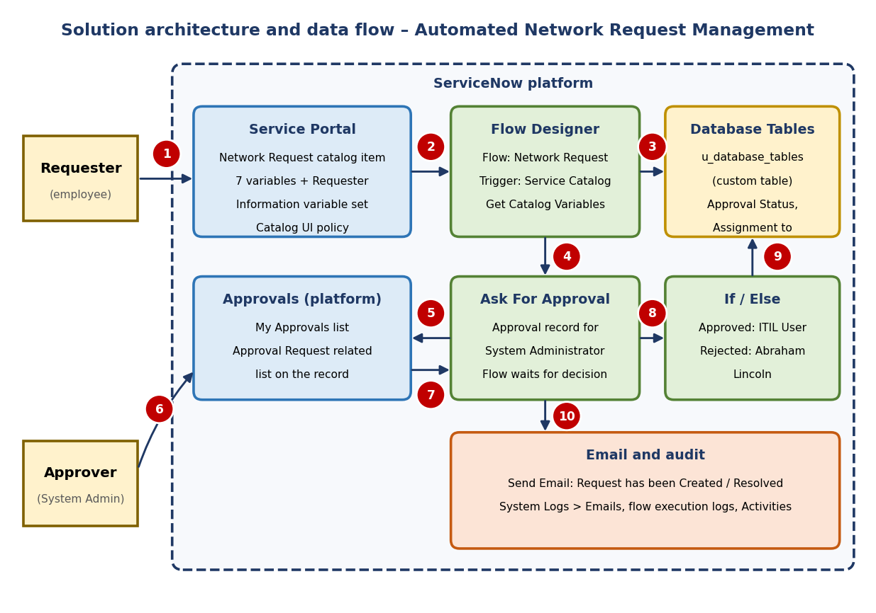
Figure 3: Solution architecture and data flow

5. PROJECT PLANNING & SCHEDULING

5.1 Project Planning
The project followed the five-phase roadmap from the Skill Wallet brief:
# | Milestone | What was delivered | Status
1 | Catalog creation | Network Request catalog item, category and short description | Done
2 | Form setup | Custom table and fields, seven variables, Requester Information variable set, UI policy | Done
3 | Approval integration | Flow with approval, Approved and Rejected branches, approvals related list | Done
4 | Testing and security | Approve and reject tests, default ACLs, audit enabled | Done, with one check pending
5 | Deployment | Project documentation, demo link and GitHub link | In progress

[Paste your Project Planning Phase documents here (sprint planning, schedule and any burndown details). They were not shared with me, so only the milestone table above is filled in.]

6. FUNCTIONAL AND PERFORMANCE TESTING

6.1 Performance Testing
Functional and performance tests
ID | Scenario | Expected | Actual | Result
FT-01 | Text input (Requested For, Address) | Text accepted | Accepted and stored | Pass
FT-02 | Number input (Mobile Number, Total Amount) | Valid values accepted | Accepted and stored | Pass
FT-03 | Mandatory fields | Empty submit is blocked | Not tested yet | Pending
FT-04 | Auto-populate requester details | Three fields fill in | All three filled in | Pass
FT-05 | Conditional Existing ID field | Shown for Existing only | Shown for Existing, not shown for New | Pass
FT-06 | Record creation | Record with Approval Status = Requested | Record created | Pass
FT-07 | Flow connection | Run appears after each order | Runs listed | Pass
FT-08 | Approval and status update | Approved and Rejected values set | Both paths correct | Pass
FT-09 | Email notifications | Created and Resolved emails listed | Both found | Pass
PT-01 | Flow run time | Run completes without error | Completed runs took 2,186 to 15,081 | Pass
PT-02 | Repeated submissions | Every run completes | Six runs after the fix all completed | Pass

Flow run times observed (Runtime column, in milliseconds as reported by the platform)
Run start (instance time) | State | Runtime
2026-10-02 04:12:03 | Error (invalid recipient, before the fix) | 11,059
2026-10-02 04:59:28 | Complete | 15,081
2026-10-02 07:39:35 | Complete | 3,750
2026-10-02 21:50:27 | Complete | 2,186
2026-10-02 22:27:16 | Complete | 7,414
2026-10-02 23:06:03 | Complete | 5,506
2026-10-04 00:45:48 | Complete | 9,114

Load testing with many users was not run, because a developer instance is not suited to it.
Problems found and fixed during testing
Bug | Problem | Fix | Status
BG-001 | Phone Number did not auto-fill | Auto populate pointed to Business phone, which was empty; changed to Mobile phone | Closed
BG-002 | Only the standard approval flow ran | Catalog item was not linked to the flow; set Process Engine > Flow | Closed
BG-003 | Flow failed at Send Email | To field used Requested For; used the email variable instead | Closed
BG-004 | Two approvals per record | Older flow Network Database Approval was deactivated | Closed
BG-005 | Activities box empty | Added a journal field and selected the fields shown | Closed
BG-006 | No Resolved email | Added a Send Email action in the Approved branch | Closed

7. RESULTS

7.1 Output Screenshots
Observed results: a request placed on 4 October 2026 (order REQ0010026, record RITM0010026) was created with Approval Status = Requested, and after approval showed Approval Status = Approved and Assignment to = ITIL User, with Mobile Number 9878685848, Total Amount 500, Mode of Payment credit_card and Type of Connection new. An earlier rejected request (RITM0010019) showed Approval Status = Rejected and Assignment to = Abraham Lincoln.
Screenshot 1: Catalog item Process Engine tab with Flow = Network Request
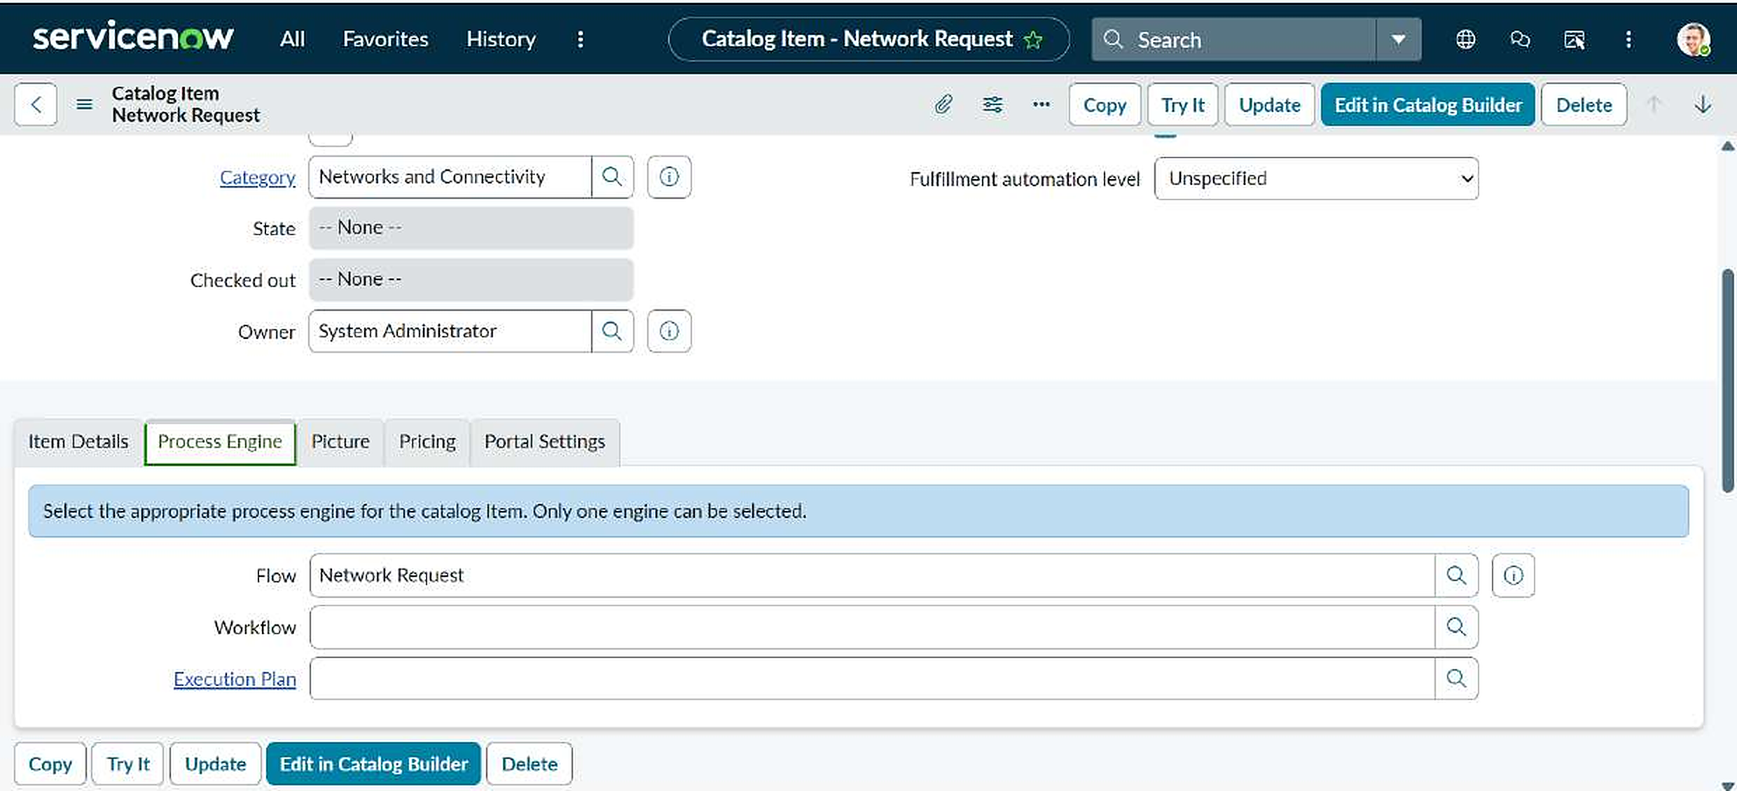
Screenshot 2: Catalog form with email, user name and phone filled in after selecting Abraham Lincoln
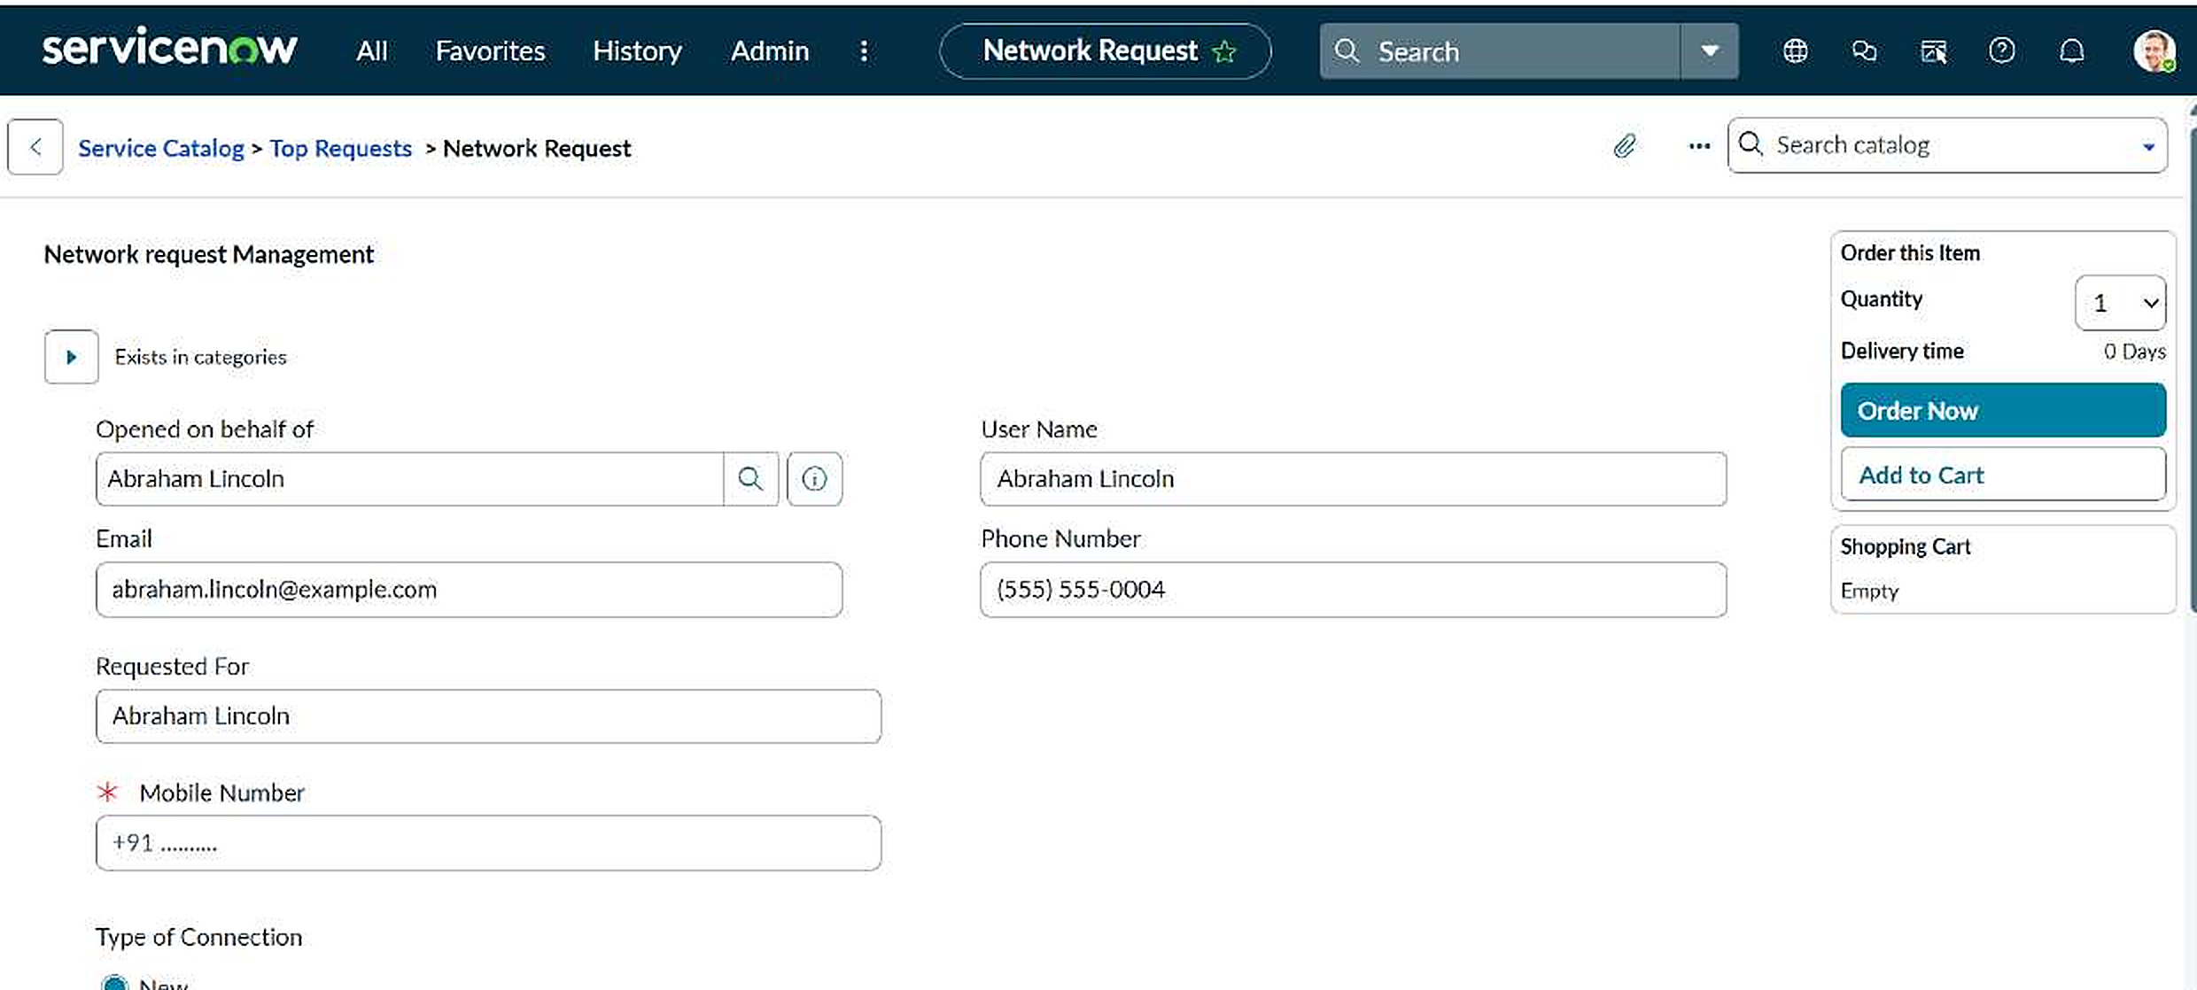
Screenshot 3: Form with Existing selected and the existing ID field visible
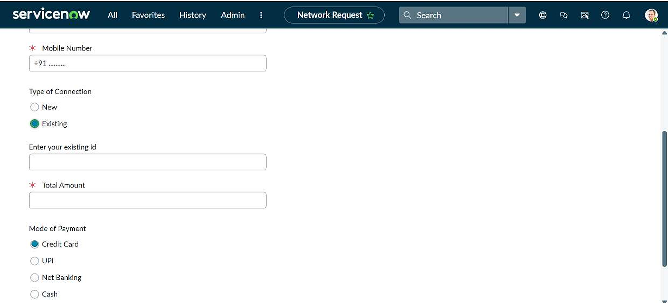
Screenshot 4: Order Status with the request number REQ0010026
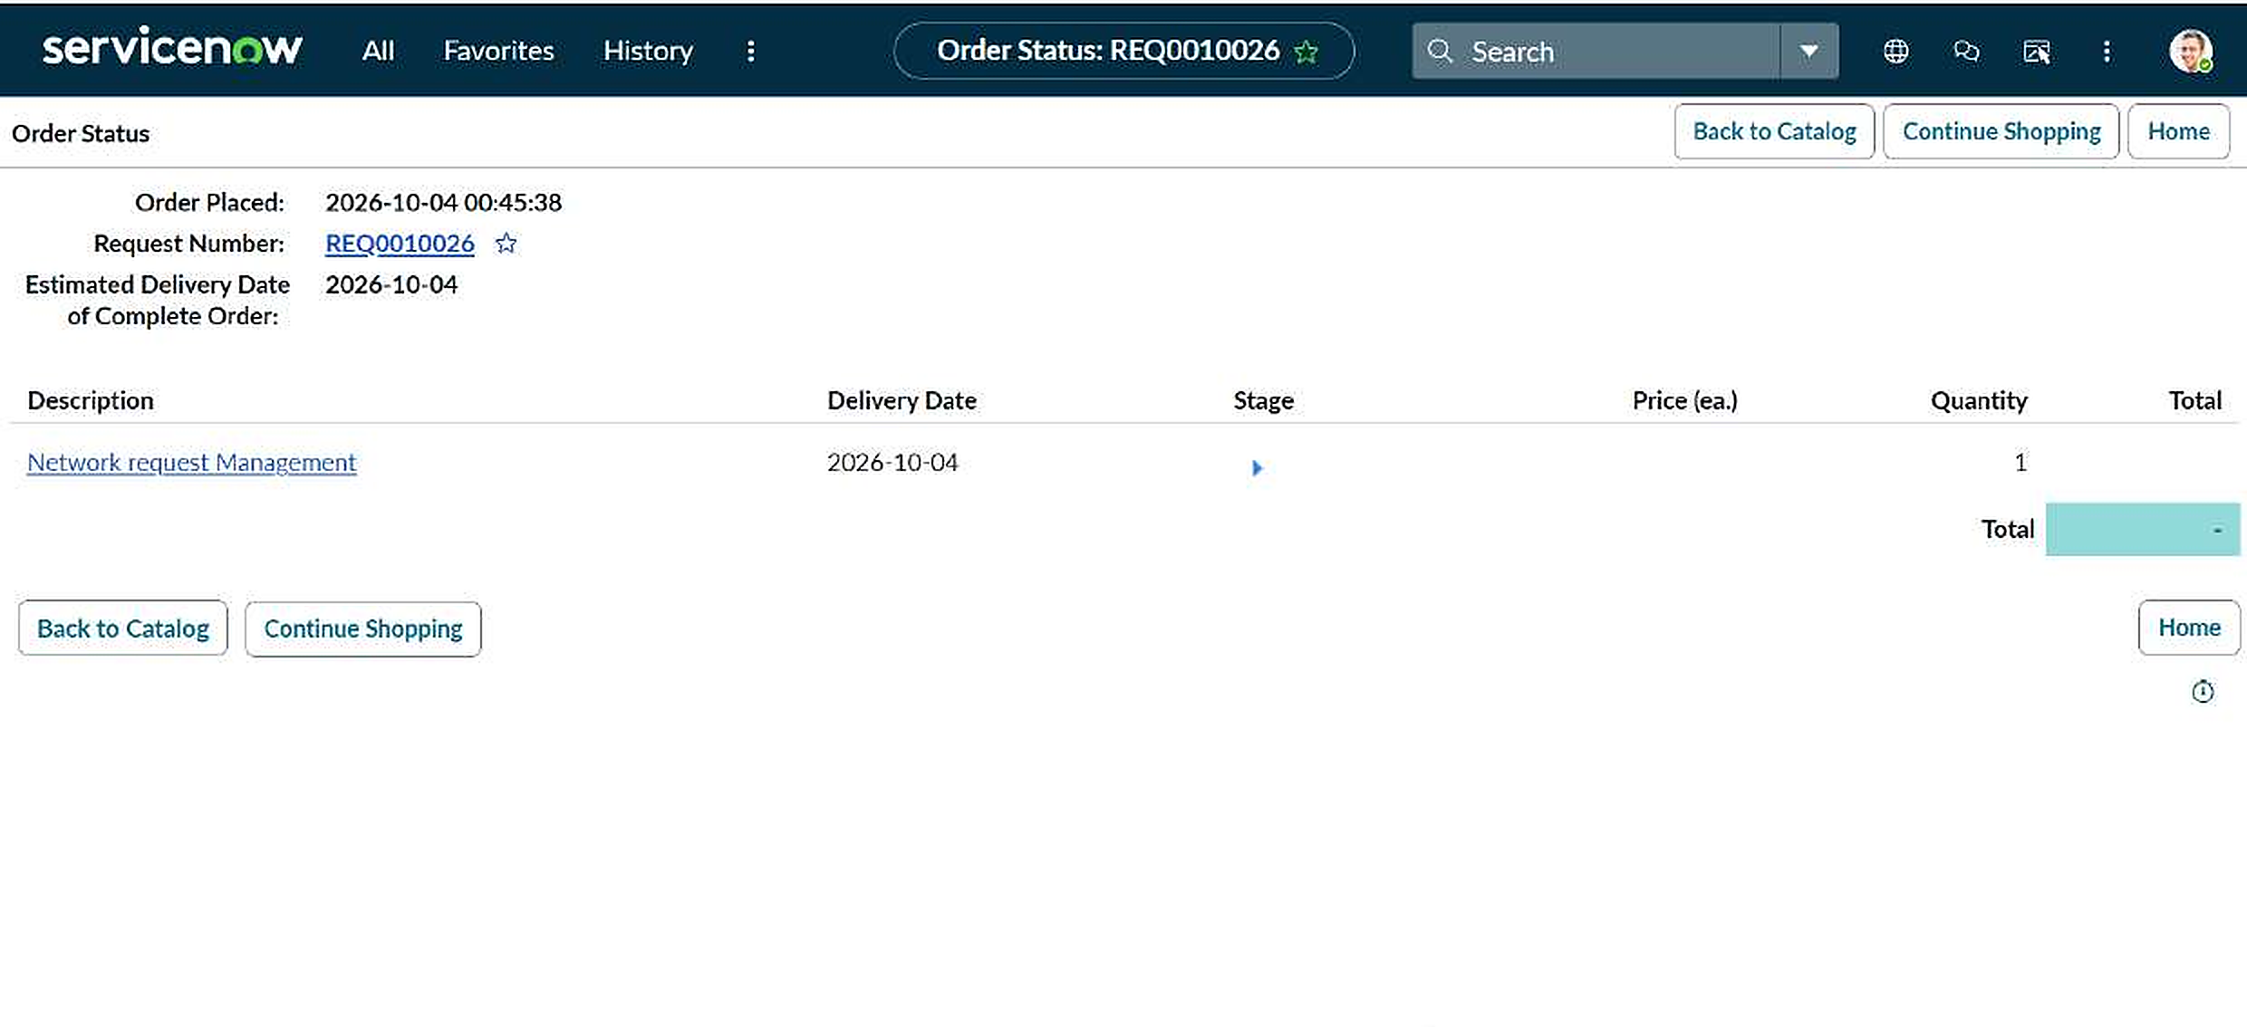
Screenshot 5: Flow Designer: Network Request flow, Active and Published
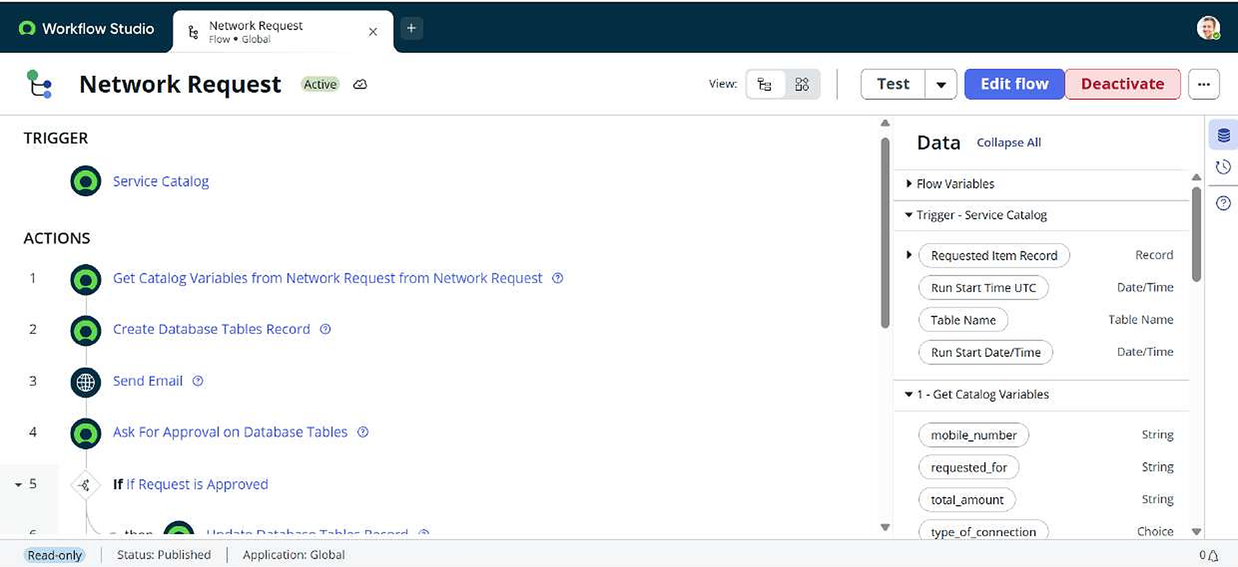
Screenshot 6: Flow executions: Network Request run with state Complete
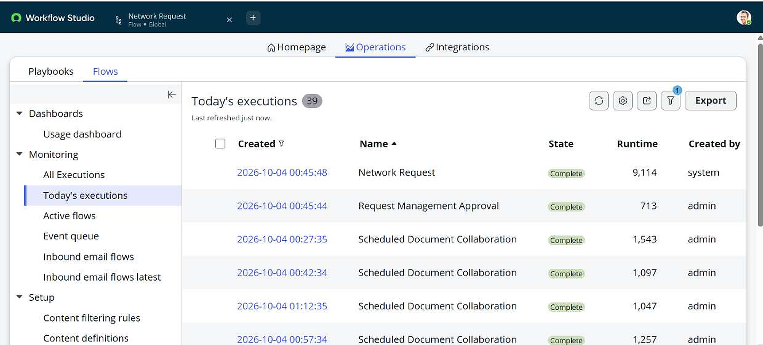
Screenshot 7: System Logs > Emails: Request has been Created and Request has been Resolved
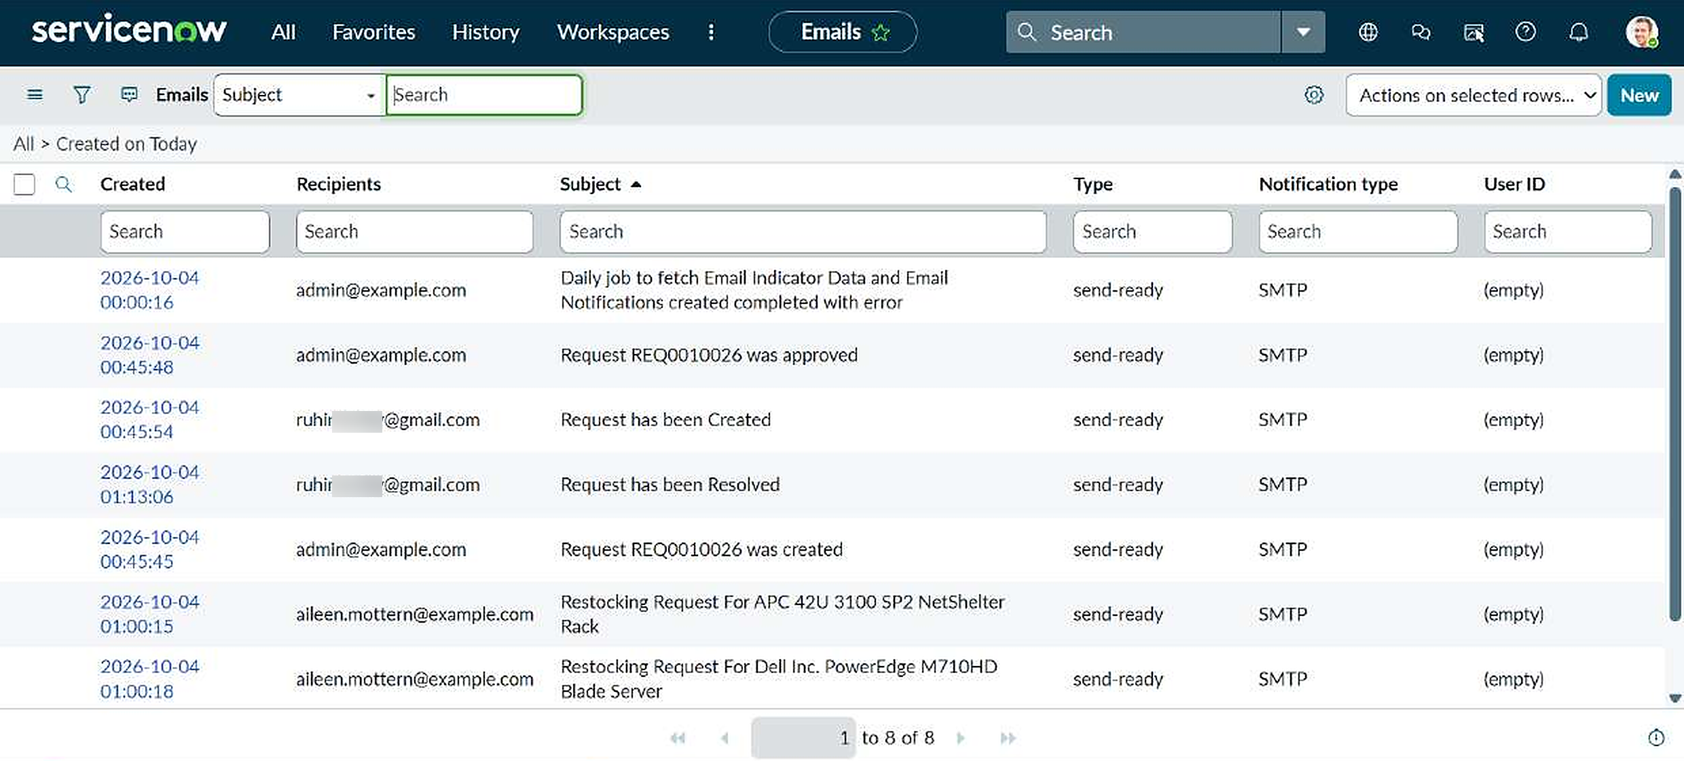
Screenshot 8: Database Tables record RITM0010026: Approved, Assignment to ITIL User
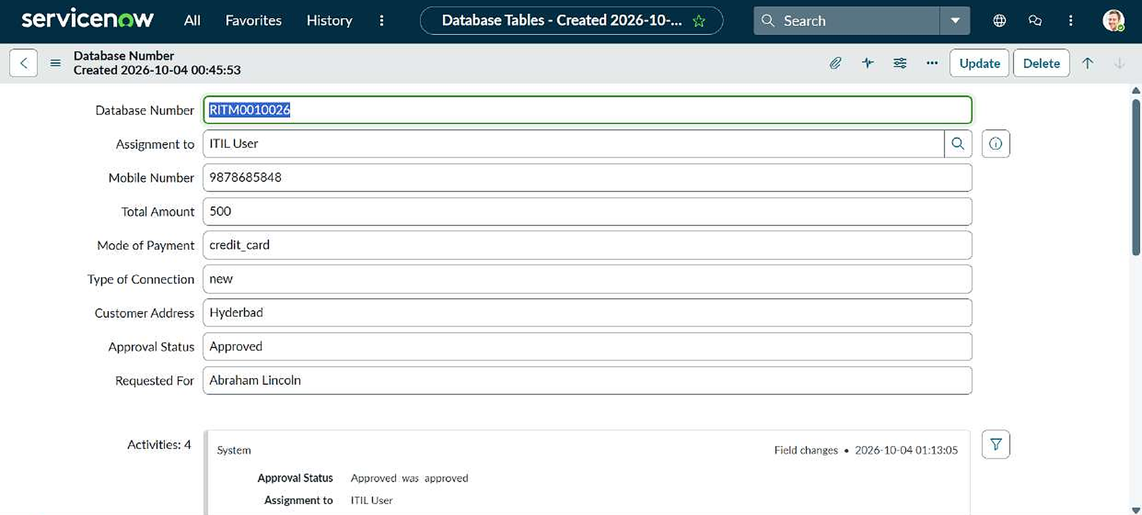
Screenshot 9: Database Tables list: approved records, and RITM0010019 Rejected with Assignment to Abraham Lincoln
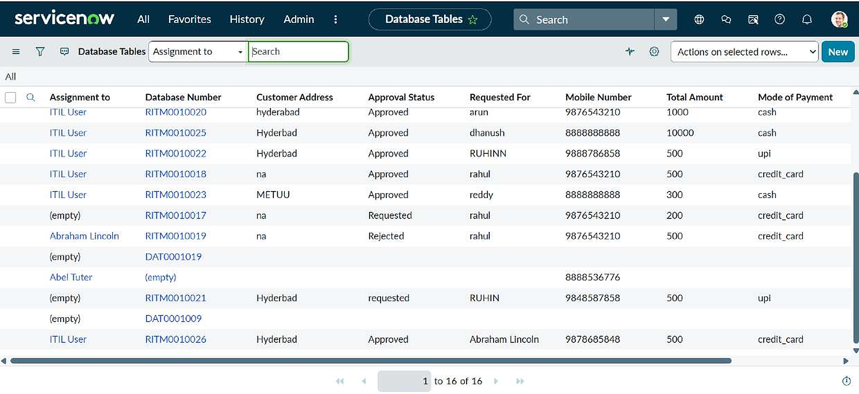
Screenshot 10: Activities box of RITM0010026 with the field changes
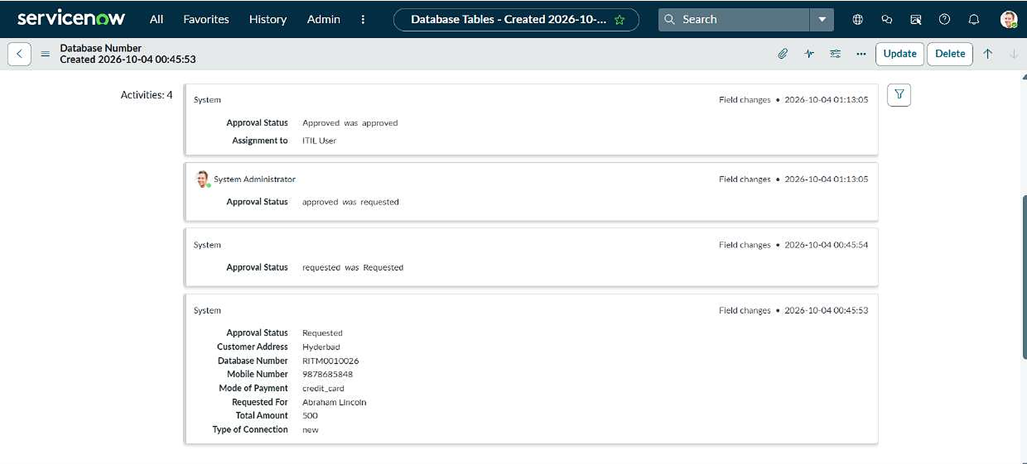

8. ADVANTAGES & DISADVANTAGES
Advantages
- Less manual work: records, emails and status updates happen automatically.
- One standard form and approval path, so request data is consistent.
- Requester details fill in automatically, which saves time and avoids typing errors.
- Built with configuration only, so an administrator can maintain it without coding.
- Clear audit trail through approvals, emails, flow logs and Activities.
Disadvantages
- Every request goes to one approver (System Administrator); there is no routing by request type or priority.
- Emails stay in the send-ready state in a developer instance and are not actually delivered.
- There is no task table for the network team, so fulfilment is not tracked after approval.
- Approval Status is a text field, so values such as Requested and requested can differ.
- The Existing ID is collected on the form but is not stored in the table.
- One check (mandatory fields) is not tested yet, and no load test was run.

9. CONCLUSION
The project delivers an automated network request process in ServiceNow. A requester submits one form, and the platform creates the record, sends emails, asks for approval and updates the status without manual steps. Both the approve and reject paths were tested and give the expected results. Several problems were found and fixed during testing: the phone auto-fill, the missing link between the catalog item and the flow, the invalid email recipient, a duplicate approval from an older flow, the empty Activities box and the missing Resolved email.

10. FUTURE SCOPE
- A Network Task table with automatic fulfilment tasks and an assignment group.
- Different approvers by request type or priority, including manager, network security and group approvals.
- Dashboards and SLA reports for approvals and fulfilment.
- A rejection email and reminders for pending approvals.
- A choice field for Approval Status, to keep values consistent.
- A requester status tracker in the Service Portal.

11. APPENDIX
Source code
The solution uses no custom script includes or business rules. The only script is the query of the Approval Request relationship (Applies to Database Tables, queries from Approval):
(function refineQuery(current, parent) {
current.addQuery('source_table', parent.getTableName());
current.addQuery('document_id', parent.sys_id);
})(current, parent);
Dataset link
Not applicable. The project uses data created in the ServiceNow instance.
GitHub & Project Demo Link
[GitHub link: add after you create the repository]
[Project demo video link: add after you record the demo]

